- Install nginx and run nginx on port number 81.

To install nginx the command used is
Yum install nginx

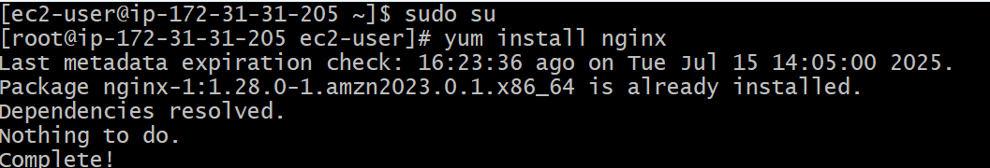

To start n check status of nginx the command as follows
Systemctl start nginx
Systemctl status nginx
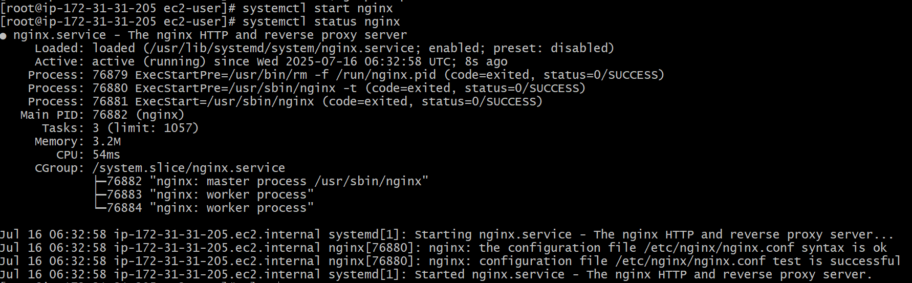

To check running services of nginx ,, to check running services on port number 80 ,,
& to check which service running on port number 80 --- the commands as follows

ps -ef | grep nginx
netstat -na | grep 80
lsof -i tcp:80
To find the path of nginx configurations the command is
Find / -name nginx.conf
We need to edit the nginx.conf by command “vi’

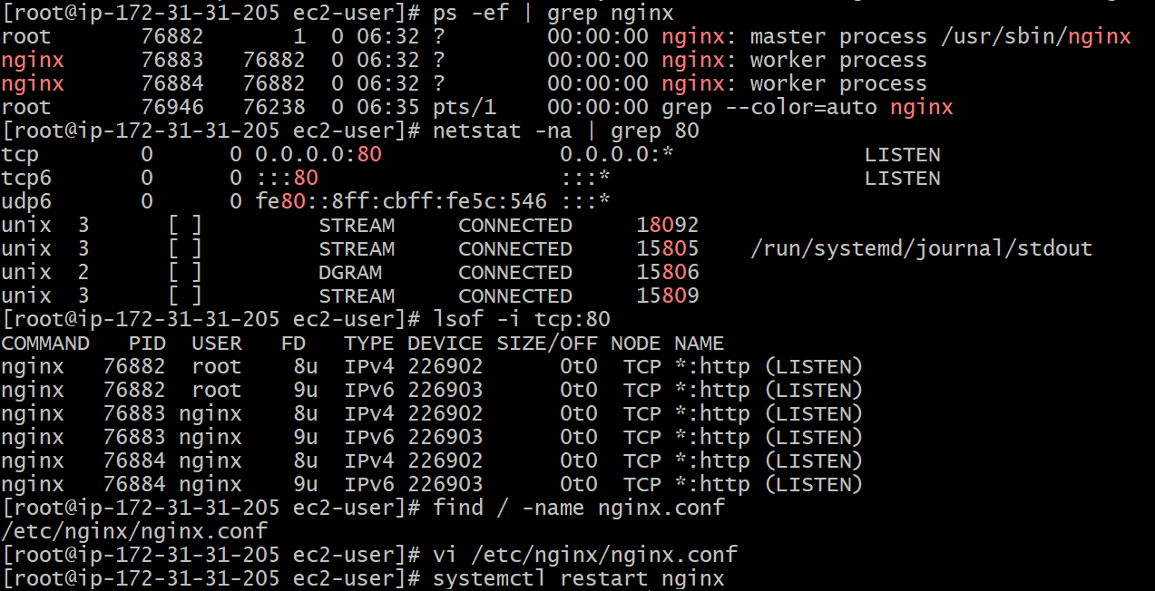

As we need to run nginx on port 81 , change nginx.conf to 81 wr required ,, save n exit

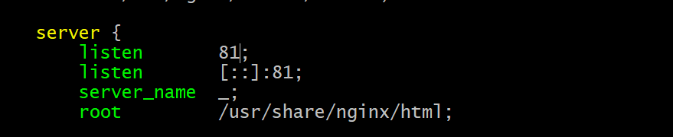

Restart the nginx and check status

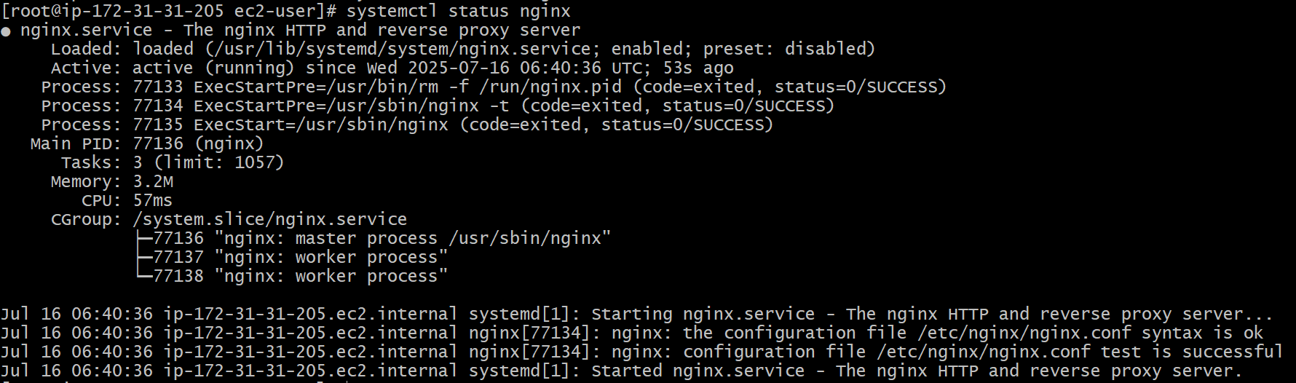

Now we can run the nginx on port number 81.

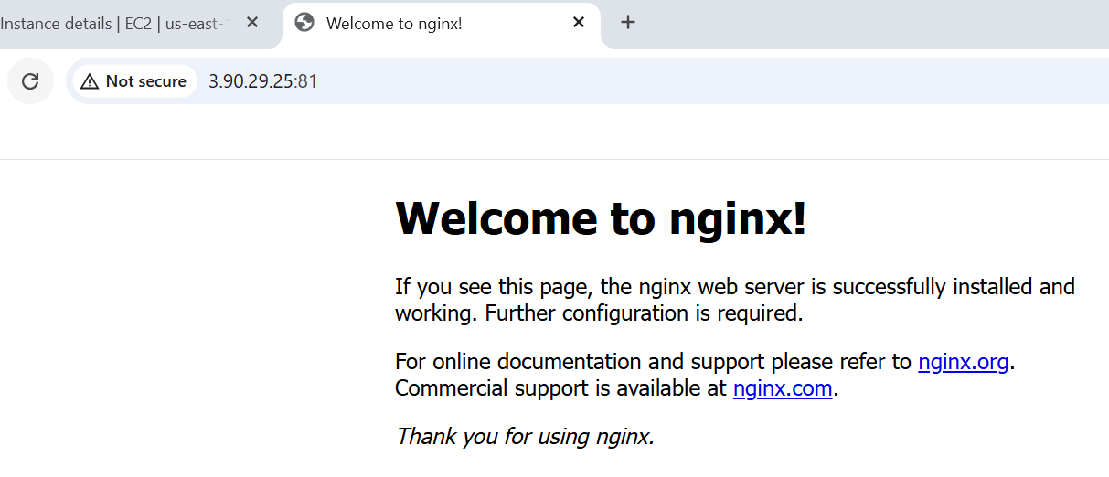

- Deploy a sample index.html file on nginx.

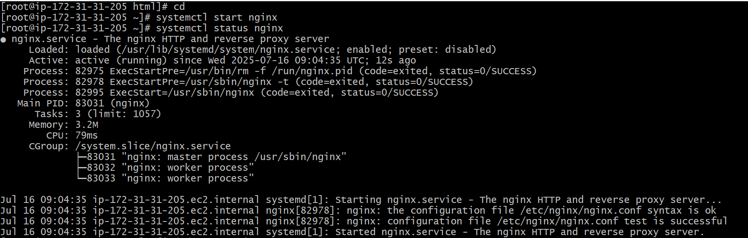

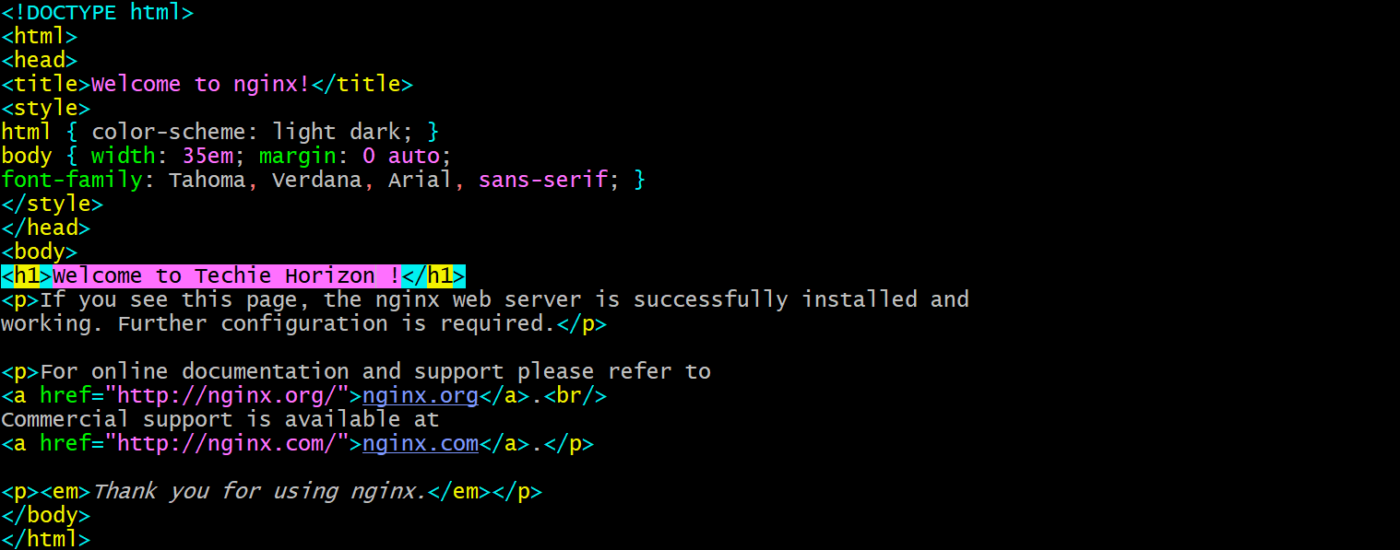

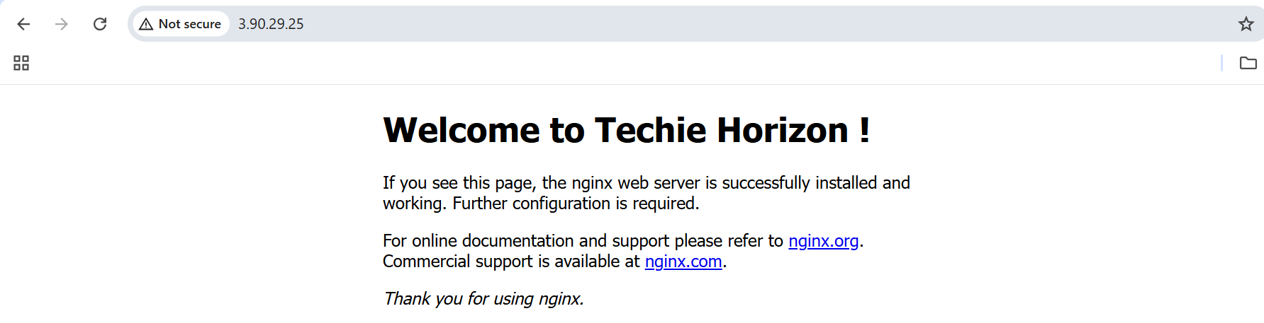

- Install Apache and run Apache on port number 82

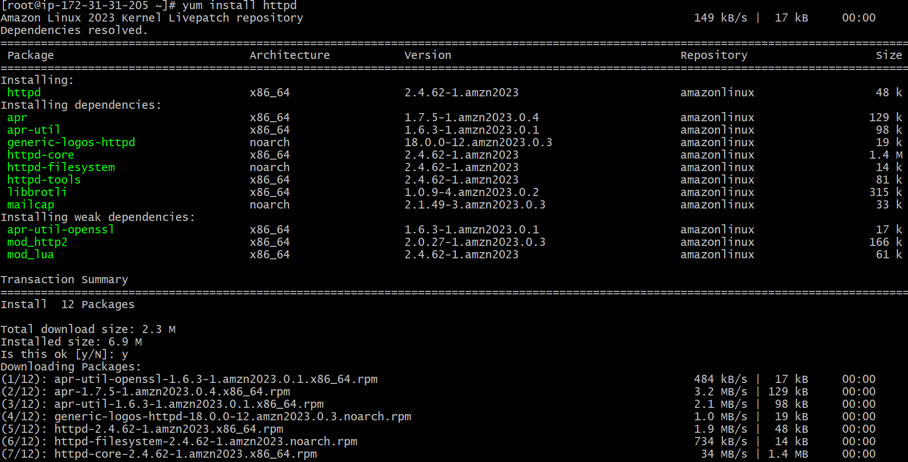

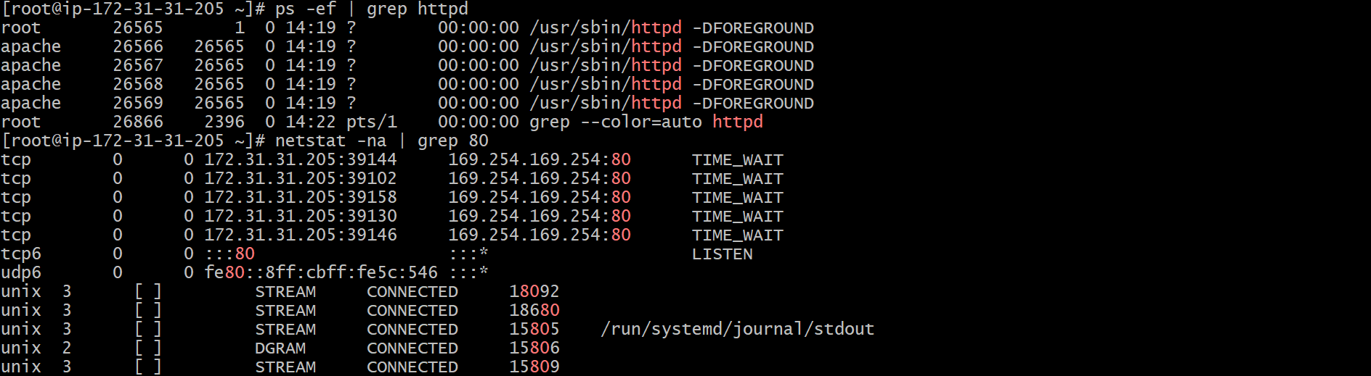

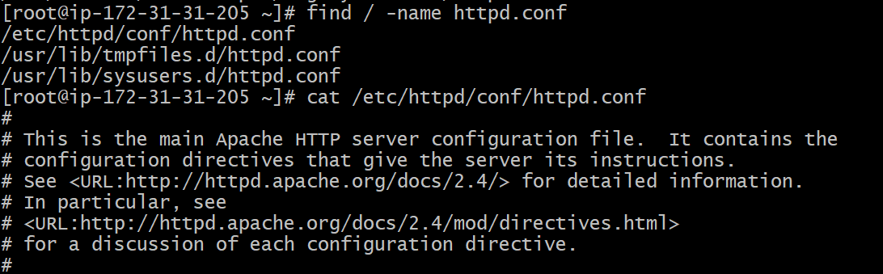

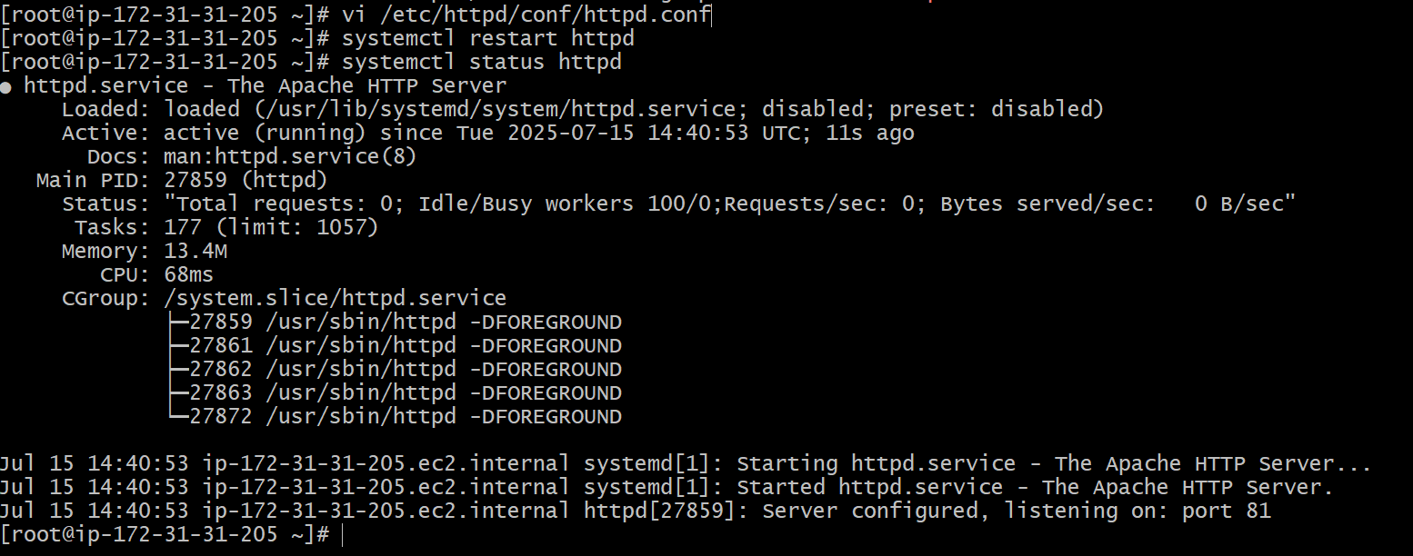

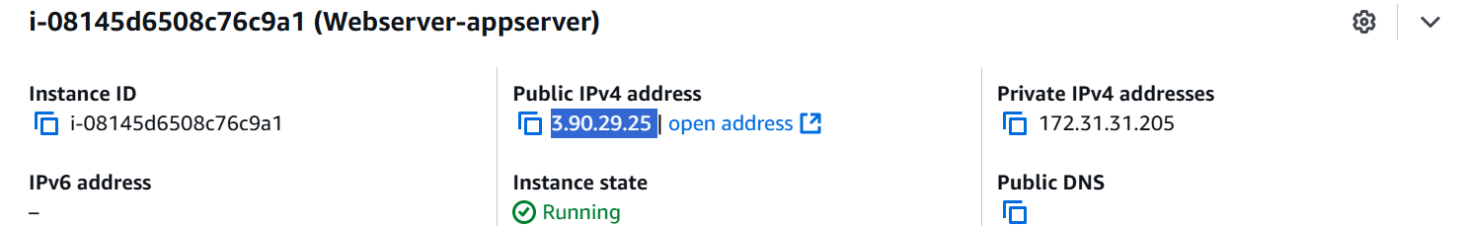

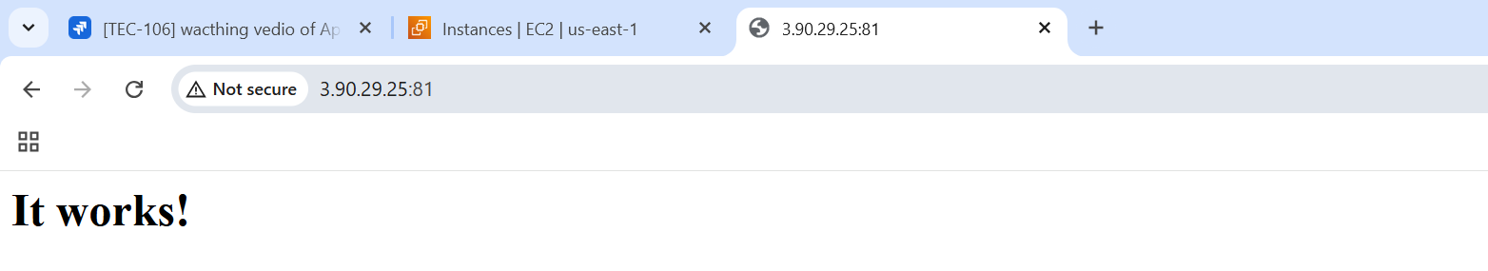

- Deploy a sample index.html file on Apache.

its the default locaation of httpd

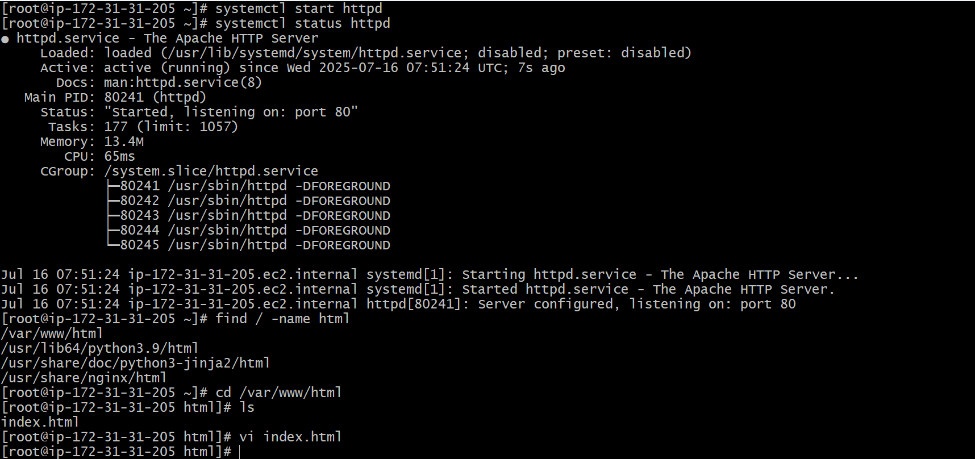



- Install Apache tomcat on port number 8082.

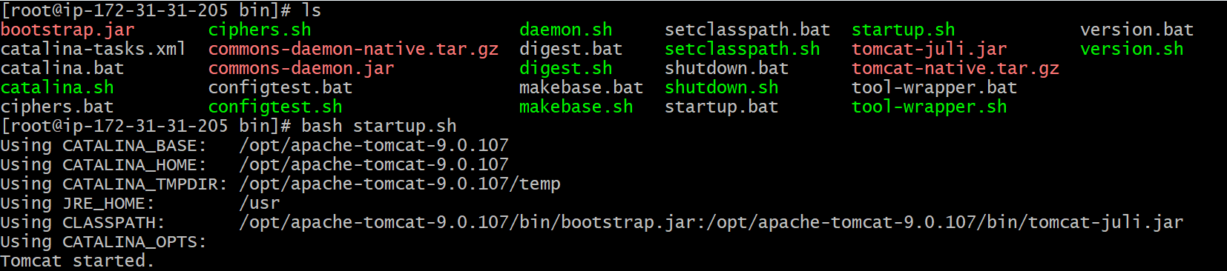

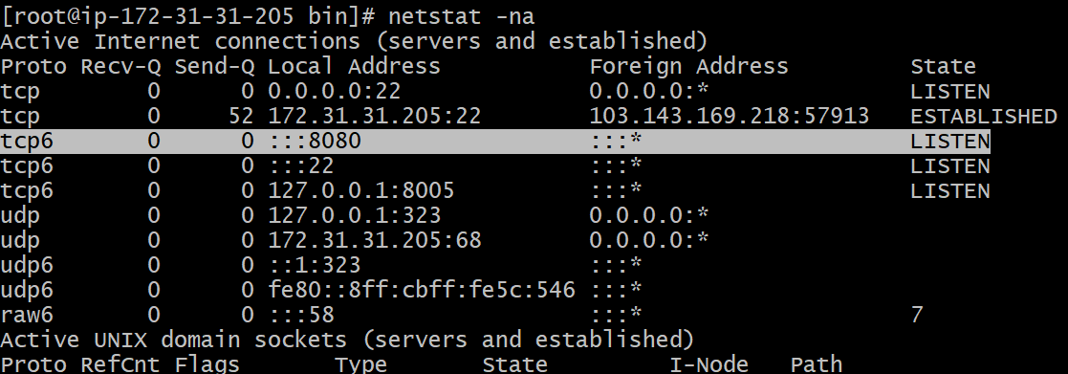

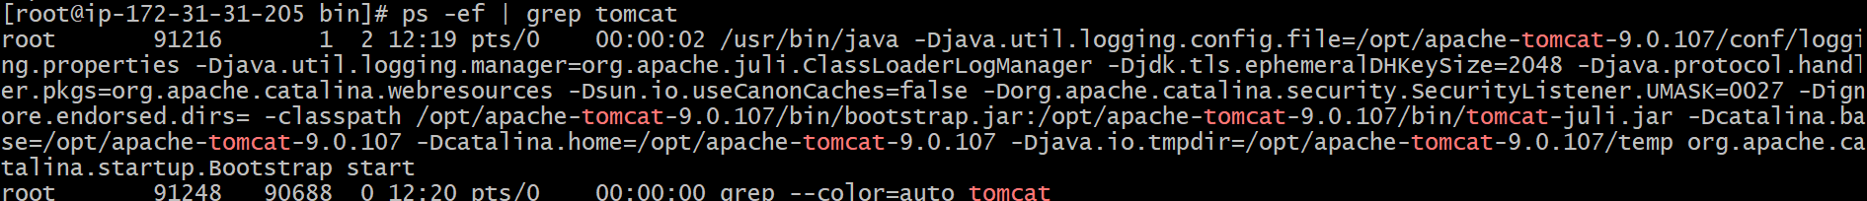

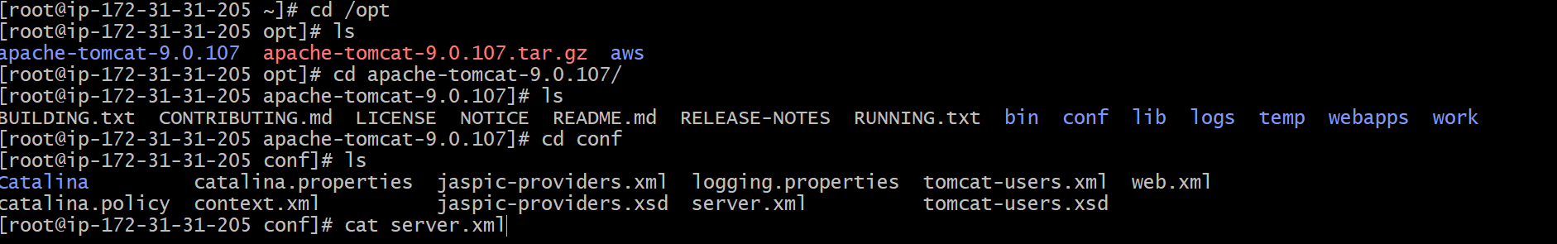

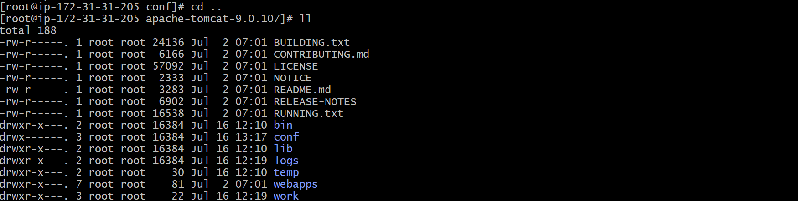

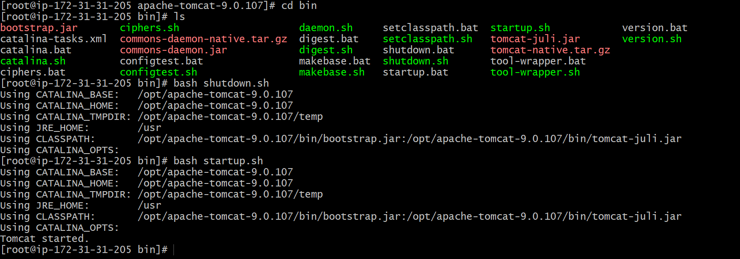

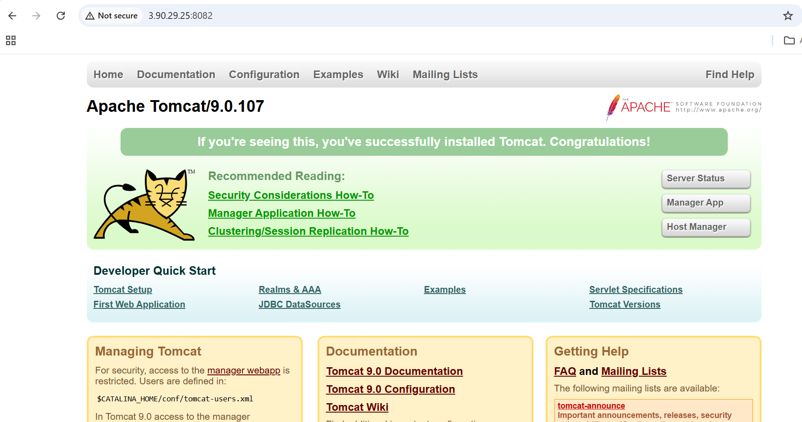

- Deploy a sample app on webapps

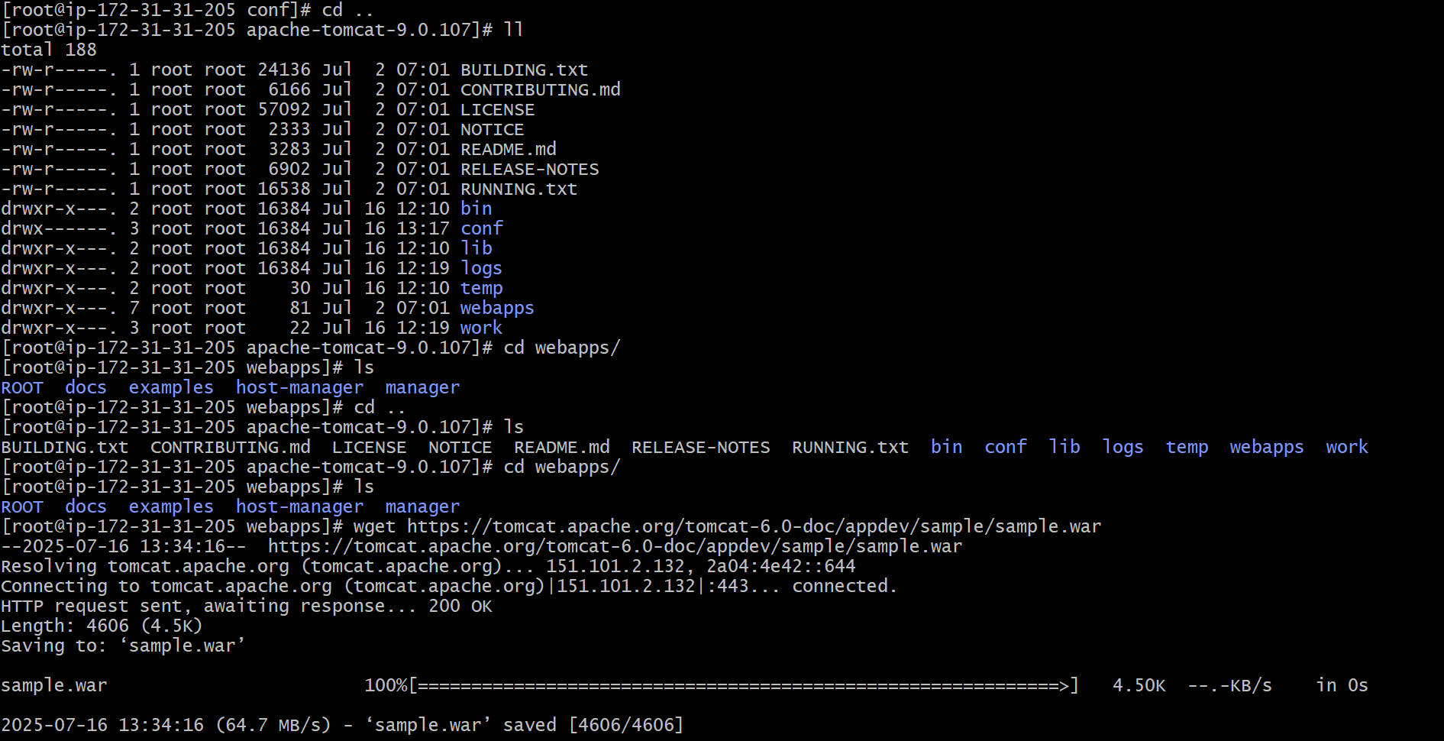

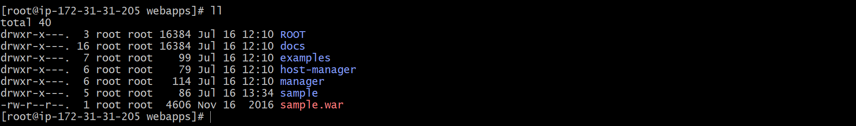

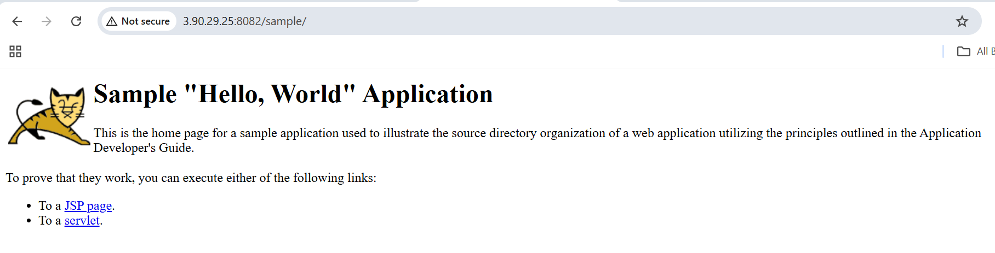

- Create a tomcat.service file for tomcat.

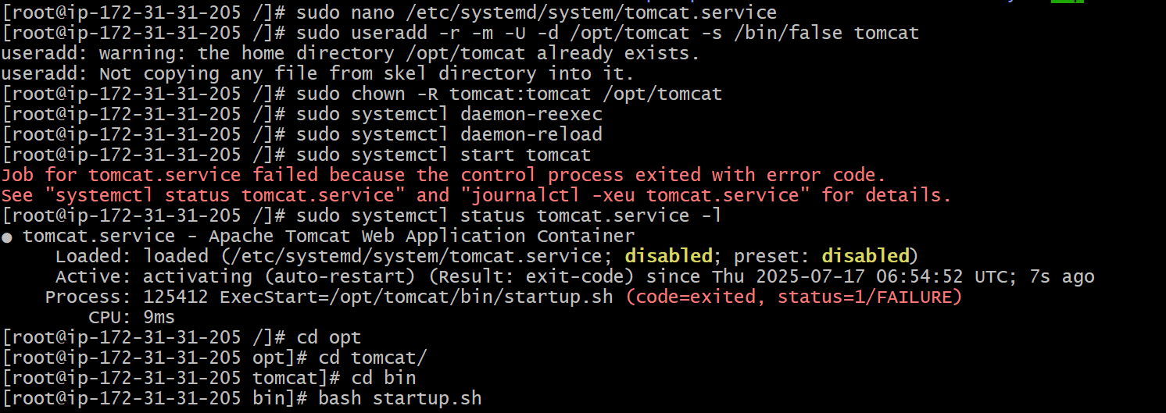

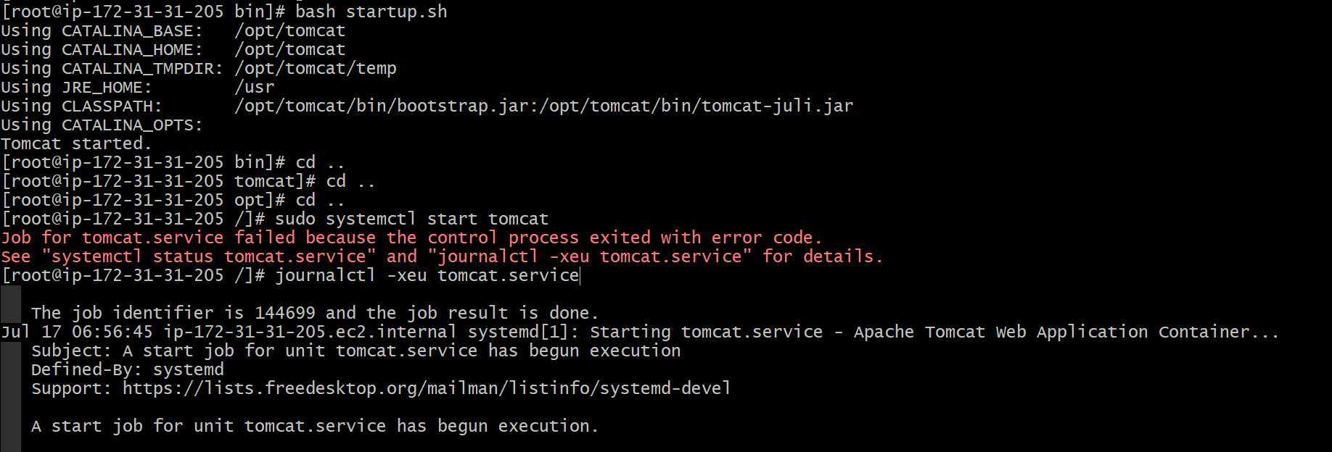
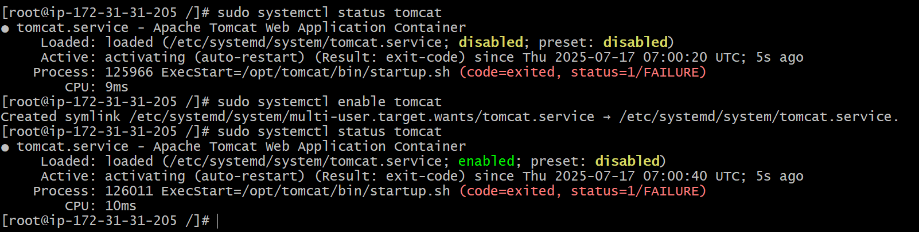

- Configure HA Proxy server.

